The Effects of Skipping Breakfast to the Academic Performance of Senior High School

A Research Presented to
The Faculty of the Senior High School Department
Mataas na Paaralng Juan C. Laya
San Manuel, Pangasinan

In Partial Fulfilment
The Requirements of the Subject
PRACTICAL RESEARCH I

By:
Researchers:
Ernest John Abalos
Yves Steven Barro
Geevy Allen Collado
Catherine Joyce Membrere
Maria Nina Balleras
Analene Estacio
Cherish Daphne Quetives

Second Semester of School Year 2019-2020
ACKNOWLEDGEMENT

This research study will not be successful without the help and support of many people around us. We would like to express our deep and sincere gratitude to the following who have supported us to complete the research work directly or indirectly.
Above all, praises and thanks to the God, the Almighty, for His showers of blessings throughout our research work to complete the research successfully.
Our respected assistant school principal Ma’am Loida Corpuz, who gave the valuable guidance and support.
To our instructor, Sir Primar Servitillo, for giving us the opportunity to do research, providing invaluable guidance throughout this research, and for helping us with our mistake. It was a great privilege and honor to work and study under his guidance.
To our beloved parents, who gave us strength when we thought of giving up, who continually provide their moral, spiritual, emotional, and financial support.
Lastly, to our friends who shared their words of advice and encouragement to finish our study.

DEDICATION
The researcher dedicated this study “The effects of skipping breakfast to the academic performance of Senior High School” to our beloved fellow classmates, friends and of course to our family. To all the people who always helped and supported us through the study, our patient teacher, who have motivated us in making this researcher possible and inspired us to continue and give our best to fulfill this research.
The researcher expresses their sincere appreciation and thank to our teacher who guide us and fellow friends that had directly and indirectly help us throughout this research project.

Chapter I
Introduction
A. Background of the Study
It is said that breakfast is the most important meal of the day, and majority of Filipinos agree. However, lack of time and other obstacles push them to skip it. According to the survey conducted in February, majority or 69 percent of Filipinos consider breakfast extremely important, with 86 percent choosing it as the most important meal of the day. In comparison, only 11 percent of respondents opt for lunch and 2 percent favor dinner. Looking closely at the breakfast habits of consumers in the Philippines, the survey found that 84 percent of respondents do make it a priority to eat their first and most important meal of the day at home, with 67 percent doing so within one to two hours of waking. The rest would just grab their breakfast either at work (10 percent) or on the way to work (4 percent). Only 2 percent of Pinoys do not eat breakfast.
In the Mataas na Paaralang Juan C. Laya, many students skip their breakfast due to lack of time. Poor time management is causing them to skip breakfast. Sleeping up late is also causing them to wake up late and to skip their breakfast.

B. Statement of the Problem
This study entitled “The effects of Skipping Breakfast to the Academic Performance of Senior High School” aimed to determine the possible effects of skipping breakfast to the students.
Specifically, it seeks to answer the following questions:
1. What are the reasons why students skip their breakfast?
2. What are the effects of skipping breakfast to the academic performance of students?
3. What are the level of academic performances of students who skip their breakfast?
C. Theoretical Framework
Figure 1.
Skipping Breakfast
Academic Performance

Our theory is that skipping breakfast has an effect to the academic performances of the senior high school students. Angela Betsaida B. Laguipo also states that skipping breakfast can affect academic performance.

D. Conceptual Framework
Figure 2.
Input Process Output
Senior High School Students

Skipping Breakfast
Effects on Academic Performance

This diagram shows the process on how the researchers will conduct the study. It also serves as a guideline in conducting the study.
E. Significance of the Study
The result of the study will be of great benefit to the following:
Students. This study encourages students to eat their breakfast to be healthy. This study also helps students to have a better academic performance in class.
Parents. The parents of the students will benefit from this study because it encourages their children to eat their breakfast and to avoid unnecessary events.
Canteen. School canteens will benefit from this study because it encourages students to eat their breakfast and if the students forgets to eat his or her breakfast he or she will go to the canteen to eat their breakfast.
Future Researchers. Future researchers will benefit from this study because they use this as a source of information related to their study. Future researchers can continue to conduct this study for the improvement of this study.
F. Scope and Delimitation
The focus of this study is to encompass the perspective of the Senior High Students at Mataas Na Paaralang Juan C.Laya for the negative effects of skipping breakfast to the student's academic performance. The researchers will be doing this from the month of January to February in the year 2020 . The researchers will only use senior high school students as respondents. The researchers will use quota and purposive sampling.
G. Limitation of the Study
The researchers will not extend the conduction of this research until March 2020. The researchers will not conduct the research on senior high school students from other schools except from the Mataas na Paaralang Juan C. Laya. The researchers will not use other sampling method other than the quota and purposive sampling
H. Definition of Terms
1. Breakfast - The first meal of the day especially when taken in the morning, the most important meal to start your day because it will give you nutrients and energy that can make your whole body work throughout the day.
2. Senior High School - Senior high school is a secondary school that students attend in the three or four highest grades before college.
3. Academic Performance - also called “academic achievement” is the extent to which a student, teacher or institution has attained their short or long terms educational goals. Completion of educational benchmarks such as secondary school diplomas and bachelor’s degrees represent academic achievement.

Chapter II
Review of Related Literature and Related Studies
“The claim that breakfast is the most important meal of the day has an abundance of sound science behind it. Breakfast is continually suggested to be a critical feature of eating regimens since it is associated with a healthier intake of nutrients, BMI and lifestyle. Several studies have shown the importance of having breakfast to the body's performance. Moreover, recent studies have demonstrated that breakfast enhances intellectual capacity, concentration, attention and academic performance. However, there is a paucity of studies which examine the relationship between breakfast consumption and academic performance.”(Taha, and Rashed, 2013).
“Breakfast, the first meal of the day, is considered the most important meal throughout the day. As nutritionist Adelle Davis famously put it back in the 1960s: “Eat breakfast like a king, lunch like a prince and dinner like a pauper”. Breakfast is most commonly skipped meal more than lunch and dinner specifically in the young adult in the university study period and those who wake up late. Lack of time is the main reason behind skipping meals, in general, lack of appetite, inability to cook, fasting/religion, and not being hungry. Many people are used to be in a hurry for job, business, children’s school in the morning where a filled stomach may prevent them to walk a long way. It is obvious that the irregular omission of breakfast may be effective in energy intake reduction over the next 24 hours and in this day, exercise performance may be compromised. There is no evidence that breakfast skipping reduces overeating or prevent weight gain. Some people argue that breakfast and good health is a marketing strategy by breakfast companies.” (Mohiuddin, 2018).
“The new study is the first to evaluate breakfast’s impact on the risk of cardiovascular death. Researchers used data from the National Health and Nutrition Examination Survey, an annual survey from the U.S. Centers for Disease Control and Prevention. The researchers used data from 6,550 Americans age 40 to 75 years gathered between 1988 and 1994 who were asked how often they ate breakfast. Among them, 5.1 percent reported never eating breakfast, 10.9 percent said they rarely ate breakfast, 25 percent said they ate breakfast some days, and 59 percent said they ate breakfast every day. Analysis found that those participants who never ate breakfast were 87 percent more likely to die from cardiovascular disease and stroke than those who ate breakfast every day, after accounting for demographic, socioeconomic, dietary, lifestyle, body mass index, and cardiovascular risk factors. Bao says skipping breakfast was associated with elevated blood pressure and changes in appetite so that a person doesn’t feel full and overeats later in the day. It also leads to harmful changes in lipid levels, such as higher levels of total cholesterol and low-density lipoprotein cholesterol, or “bad cholesterol,” which leads to an increased likelihood of cardiovascular disease.” (Bao, 2019).
“Children often hear their parents say that breakfast is the most important meal of the day. It fuels the body for a long day’s work or school. That adage is true as a new study shows that skipping breakfast is tied to lower scores in high school performance tests. The General Certificate of Secondary Education (GCSE) is a set of examinations taken in Wales, England, Northern Ireland and other British territories that are usually taken by students between 15 and 16 years of age. It provides a uniform framework for the assessment of students. A team of researchers at the University of Leeds wanted to see the effect of eating or skipping breakfast on the academic performance of students, particularly looking at their GCSE scores. They found that students who seldom or rarely consumed breakfast on school days had lower GCSE grades than those who are breakfast regularly. The team has demonstrated the relationship between eating breakfast and GCSE performance for secondary school students in the United Kingdom for the first time. Published in the journal Frontiers in Public Health, the study involves incorporating all of the exam results of the students. In turn, the results show that those who rarely consumed breakfast before going to school incurred nearly two grades lower than those who regularly ate their morning meal.” (Laguipo, 2019).

Chapter III
Methodology
Research Design
In able to conduct and facilitate the study, the researchers used a phenomenological approach as a research design. Operationally, this can be defined as a data being gathered through the respondents’ personal views and experience in the field. Phenomenology is an approach to qualitative research that focuses on the commonality of a lived experience within a particular group. The fundamental goal of the approach is to arrive at a description of the nature of the particular phenomenon (Creswell,2013). Althrough this research is highly accurate, it does not gather the causes behind the situation.
Sampling
The researcher used quota and purposive sampling as sampling methods to effectively facilitate the gathering of data that are used in the study. Quota sampling is a non-probability sampling technique in which researchers look for a specific characteristic in their respondents, and then take a tailored sample that is in proportion to a population of interest in this case, grade 11 students of Mataas na Paaralang Juan C. Laya. Purposive sampling also used in the study is a non-probability sample that is selected based on characteristics on a population and the objective of the study or also known as judgmental, selective or subjective sampling. to be able to do this, the researchers set criteria which are the respondents that are then observed and interviewed in Mataas na Paaralang Juan C. Laya. The researchers will use 20 respondents from the senior high school, 10 students from grade 11 and 10 students from grade 12.
Data Gathering
In this study, the researchers initiated the data gathering by first informing the school’s assistant principal about the study being conducted in the school and then by asking permission as confirmation to conduct the survey interview throught a letter. In gathering the data, the researchers first asked for the respondent’s permission to be interviewed and recorded before officially conducting it. The researchers discussed the objectives of the study to the respondents and everything was first explained and clarified before the interview. The researchers attentively listened and noted everything the respondents said during the interview.

Chapter IV
Findings and Interpretation
The research study entitled “ The Effects of Skipping Breakfast to the Academic Performance of Senior High School” discussed about how skipping breakfast affects the academic performance of senior high students.
Skipping breakfast to the Senior High School
The researchers conducted a survey to the senior high school of Mataas na Paaralang Juan C. Laya and learned that many students skip their breakfast in the morning. The respondent of the survey skip their breakfast due to some reasons.
Table 1.
Respondents’ frequency of taking their breakfast in one week
DOMAIN | CATEGORY | FREQUENCY
1. How often do you take your breakfast before going to school? | Never  Once a week  Twice a week  Thrice a week  4 Times a week | 3 respondents  9 respondents  4 respondents  1 respondent  2 respondents
The respondent’s frequency of taking their breakfast in a week ranges from 0 days to 4 days.
Table 2.
The reasons why the respondents skip their breakfast
DOMAIN | CATEGORY | FREQUENCY
2. Why do you skip your breakfast? | Lack of time  No one can cook  Not comfortable  Does’nt have appetite  Diet | 14 respondents  3 respondents  3 respondents  1 respondent  1 respondent
The respondents have different reasons why they skip their breakfast. Some of the reasons are lack of time, no one can cook, not comfortable, doesn’t have an appetite and diet.

Table 3.
What the Respondents feel when they skip their breakfast
DOMAIN | CATEGORY | FREQUENCY
What do you feel when you skip your breakfast? | Hunger  Stomachache/Headache  Tired  Unattentive  Cant Focus  No effect | 9 respondents  2 respondents  3 respondents  1 respondent  1 respondent  4 respondents
The table shows effect of skipping breakfast to the respondents. Some of the effects are hunger, tired, headache and stomachache, unattentive, and can’t focus. But some of the respondents are not affected.

Table 4.
The effects of skipping breakfast to the academic performance
DOMAIN | CATEGORY | FREQUENCY
What do you think skipping breakfast would do to your academic performance? | Cant Focus  Cant think properly  Cant perform well  Does’nt affect | 10 respondents  4 respondents  4 respondents  2 respondents
This table shows the effect of skipping breakfast to the academic performance of the respondents. The effects are can’t focus, perform well, and think properly. But the academic performance of some respondents are not affected.
Table 5
The level of academic performance of the respondents
DOMAIN | CATEGORY | FREQUENCY
What is your level of academic performance in your class? | None  With honor  With high honor | 9 respondents  9 respondents  2 respondents
This table shows the level of academic performance of the respondents. The levels of academic performance of the respondents are with honors and with high honors. But some respondents doesn’t have any level of academic performance.

Chapter V
Summary of Findings, Conclusion and Recommendation
This chapter presents the summary of the findings, conclusions and recommendations based on the analysis of the effects of skipping breakfast to the academic performance of senior high school students
Summary
The purpose of the study was to know the effects of skipping breakfast to the academic performance of Senior High School students. The following were the summary of the findings:
- The majority of the respondents are skipping their breakfast regularly.
- The respondents have different reasons why they skip their breakfast. Some of the reasons are lack of time, no one can cook, not comfortable, doesn’t have an appetite and diet.
- Based on the findings, the possible effects of skipping breakfast are hunger, tired, headache, stomachache, unattentive, and can’t focus. But some of the respondents are not affected.
- Based on the findings, the possible effects of skipping breakfast to the academic performance are can’t focus, perform well, and think properly. But the academic performance of some respondents are not affected.
- The level of academic performance of the respondents ranges from none to with high honor.
Conclusion
The research study “The Effects of Skipping Breakfast to the Academic Performance of Senior High School” has come to a conclusion regarding on the findings of the study. The following are the conclusions:
- The majority of students in senior high school skip their breakfast regularly.
- The possible effects of skipping breakfast are hunger, tired, headache, stomachache, unattentive, and can’t focus. But some of the respondents are not affected.
- The possible effects of skipping breakfast to the academic performance are can’t focus, perform well, and think properly. But the academic performance of some respondents are not affected.
- The majority of students who skip their breakfast has a level of academic performance of with honors and nothing.
Recommendations
Based on the findings, the research study makes the number of recommendations derived from drawn conclusions
- Everyone must eat their breakfast regularly.
- Everyone needs to know the importance of eating breakfast regularly.
- Further analysis and study is needed.
- Eating breakfast should be a daily need.

Bibliography
Skipping breakfast affects academic performance (2019, November). Retrived from https://www.google.com/amp/s/www.news-medical.net/amp/news/20191120/Skipping-breakfast-affects-academic-performance.aspx
Skipping Breakfast Everyday Keeps Well-being Away (2018, December). Retrieved from http://www.fortunejournals.com/articles/skipping-breakfast-everyday-keeps-wellbeing-away.html
The Effect of Breakfast on Academic Performance among High School Students in Abu Dhabi (2013, March). Retrived from https://www.google.com/amp/s/www.news-medical.net/amp/news/20191120/Skipping-breakfast-affects-academic-performance.aspx
UI study: Skipping breakfast associated with higher risk of cardiovascular death (2019, April). Retrived from https://now.uiowa.edu/2019/04/ui-study-skipping-breakfast-associated-higher-risk-cardiovascular-death
Understanding the breakfast habits of Filipinos (2018, May). Retrieved from https://manilastandard.net/mobile/article/265054

APPENDICES

Appendix A. Letter of Approval
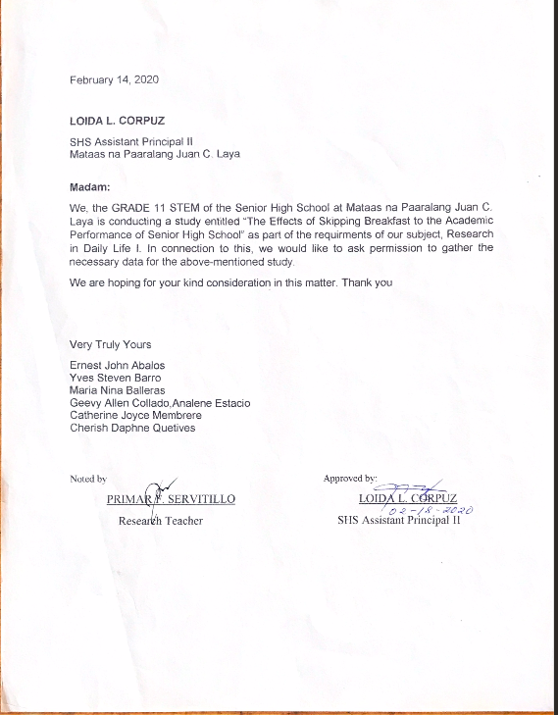


Appendix B. Questionnaire

The Effects of Skipping Breakfast to the Academic Performance of Senior High School
Name: Age:
Grade and section: Gender:

Directions: Please answer the following questions honestly

1. Do you skip breakfast regularly?

2. How often do you take breakfast before going to school?

3. Why do you skip your breakfast?

4. What do you feel when you skip your breakfast?

5. What do you think skipping breakfast would do to your academic performance?

6. What is your level of academic performance in your class?

Signature
Apendix C. Documentation






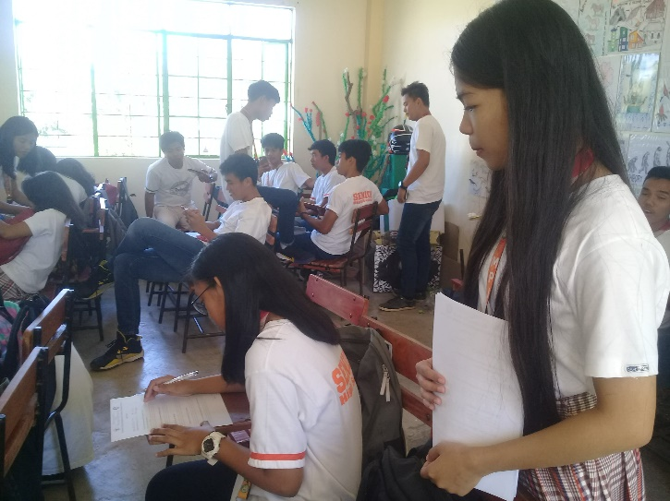\


CURRICULUM VITAE


San Bonifacio, San Manuel, Pangasinan
Mobile: 09167599400
Email:

Maria Nina Q. Balleras
PERSONAL DATA
Date of Birth: November 20, 2003
Place of Birth: San Bonifacio, San Manuel Pangasinan
Civil Status: Single
Citizenship: Filipino
Religion: Roman Catholic
Height: 155
Weight: 44
Mother’s Name: Marcelina Balleras
Father’s Name: Augusto R. Balleras Sr.

EDUCATIONAL BACKGROUND
Primary:
San Roque Elementary School
San Manuel, Pangasinan (2007-2015)
Secondary (Still Studying)
Mataas na Paaralang Juan C. Laya
Quirino Street, Guiset Sur, San Manuel, Pangasinan
CURRICULUM VITAE


San Juan, San Manuel, Pangasinan
Mobile: 09267005473
Email: katkatmembrere@gmail.com

Catherine Joyce L. Membrere
PERSONAL DATA
Date of Birth: April 17, 2003
Place of Birth: Urdaneta, City
Civil Status: Single
Citizenship: Filipino
Religion: Roman Catholic
Height: 159
Weight: 40
Mother’s Name: Gemma L. Membrere
Father’s Name: Basilio B. Membrere Sr.

EDUCATIONAL BACKGROUND
Primary:
San Juan Elementary School
San Manuel, Pangasinan (2007-2015)
Secondary (Still Studying)
Mataas na Paaralang Juan C. Laya
Quirino Street, Guiset Sur, San Manuel, Pangasinan

CURRICULUM VITAE



Flores, San Manuel, Pangasinan
Mobile: 09471523693
Email: Colladogeevy@gmail.com

Geevy Allen R. Collado
PERSONAL DATA
Date of Birth: May 28, 2003
Place of Birth: Tayug, Pangasinan
Civil Status: Single
Citizenship: Filipino
Religion: Iglesia ni Cristo
Height: 169
Weight: 68
Mother’s Name: Lalaine Collado
Father’s Name: Gilbert Collado

EDUCATIONAL BACKGROUND
Primary:
Flores, Integrated School
Flores, San Manuel, Pangasinan (2007-2015)
Secondary
Flores, Integrated School
Flores, San Manuel Pangasinan
CURRICULUM VITAE


Narra, San Manuel, Pangasinan
Mobile: 09568831981
Email: analeneestacio@yahoo.com

Analene M. Estacio
PERSONAL DATA
Date of Birth: February 16, 2003
Place of Birth: Narra, San Manuel, Pangasinan
Civil Status: Single
Citizenship: Filipino
Religion: Roman Catholic
Height: 157
Weight: 40
Mother’s Name: Evangeline Estacio
Father’s Name: Josie Estacio

EDUCATIONAL BACKGROUND
Primary:
Narra Elementary School
San Manuel, Pangasinan (2007-2015)
Secondary (Still Studying)
Mataas na Paaralang Juan C. Laya
Quirino Street, Guiset Sur, San Manuel, Pangasinan
CURRICULUM VITAE


Narra, San Manuel, Pangasinan
Mobile: 09560945453
Email: rishquetives@gmail.com

Cherish Daphne M. Quetives
PERSONAL DATA
Date of Birth: May 23, 2003
Place of Birth: Narra, San Manuel Pangasinan
Civil Status: Single
Citizenship: Filipino
Religion: Jehova’s Witnesses
Height: 163
Weight: 45
Mother’s Name: Cristina M. Quetives
Father’s Name: Jerry P. Quetives

EDUCATIONAL BACKGROUND
Primary:
Spark Academy of Global City (2007-2013)
Narra Elementary School San Manuel, Pangasinan (2013-2015)
Secondary (Still Studying)
Mataas na Paaralang Juan C. Laya
Quirino Street, Guiset Sur, San Manuel, Pangasinan
CURRICULUM VITAE


San Roque, San Manuel, Pangasinan
Mobile: 09153507665
Email: yvesteven2002@gmail.com

Yves Steven S. Barro
PERSONAL DATA
Date of Birth: November 9, 2002
Place of Birth: Urdaneta City, Pangasinan
Civil Status: Single
Citizenship: Filipino
Religion: Christianity
Height: 176
Weight: 96
Mother’s Name: Raquel S. Barro
Father’s Name: Stephen C. Barro

EDUCATIONAL BACKGROUND
Primary:
Juan C. Laya Memorial School
Guiset Sur, San Manuel, Pangasinan (2007-2015)
Secondary (Still Studying)
Mataas na Paaralang Juan C. Laya
Quirino Street, Guiset Sur, San Manuel, Pangasinan

CURRICULUM VITAE


Guiset Sur, San Manuel, Pangasinan
Mobile: 09568107313
Email: abalos.ernest@yahoo.com

Ernest John V. Abalos
PERSONAL DATA
Date of Birth: November 3, 2002
Place of Birth: Guiset Sur, San Manuel Pangasinan
Civil Status: Single
Citizenship: Filipino
Religion: Roman Catholic
Height: 162
Weight: 45
Mother’s Name: Gracelda Abalos
Father’s Name: Ernesto Abalos

EDUCATIONAL BACKGROUND
Primary:
Juan C. Laya Memorial School
San Manuel, Pangasinan (2007-2015)
Secondary (Still Studying)
Mataas na Paaralang Juan C. Laya
Quirino Street, Guiset Sur, San Manuel, Pangasinan

